36.24: Diffraction dark fringes occur for 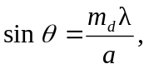 and interference maxima occur for 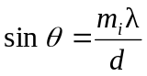. Setting them equal to each other yields a missing bright spot whenever the destructive interference matches the bright spots. That is: 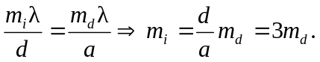 That is, the missing parts of the pattern occur for 